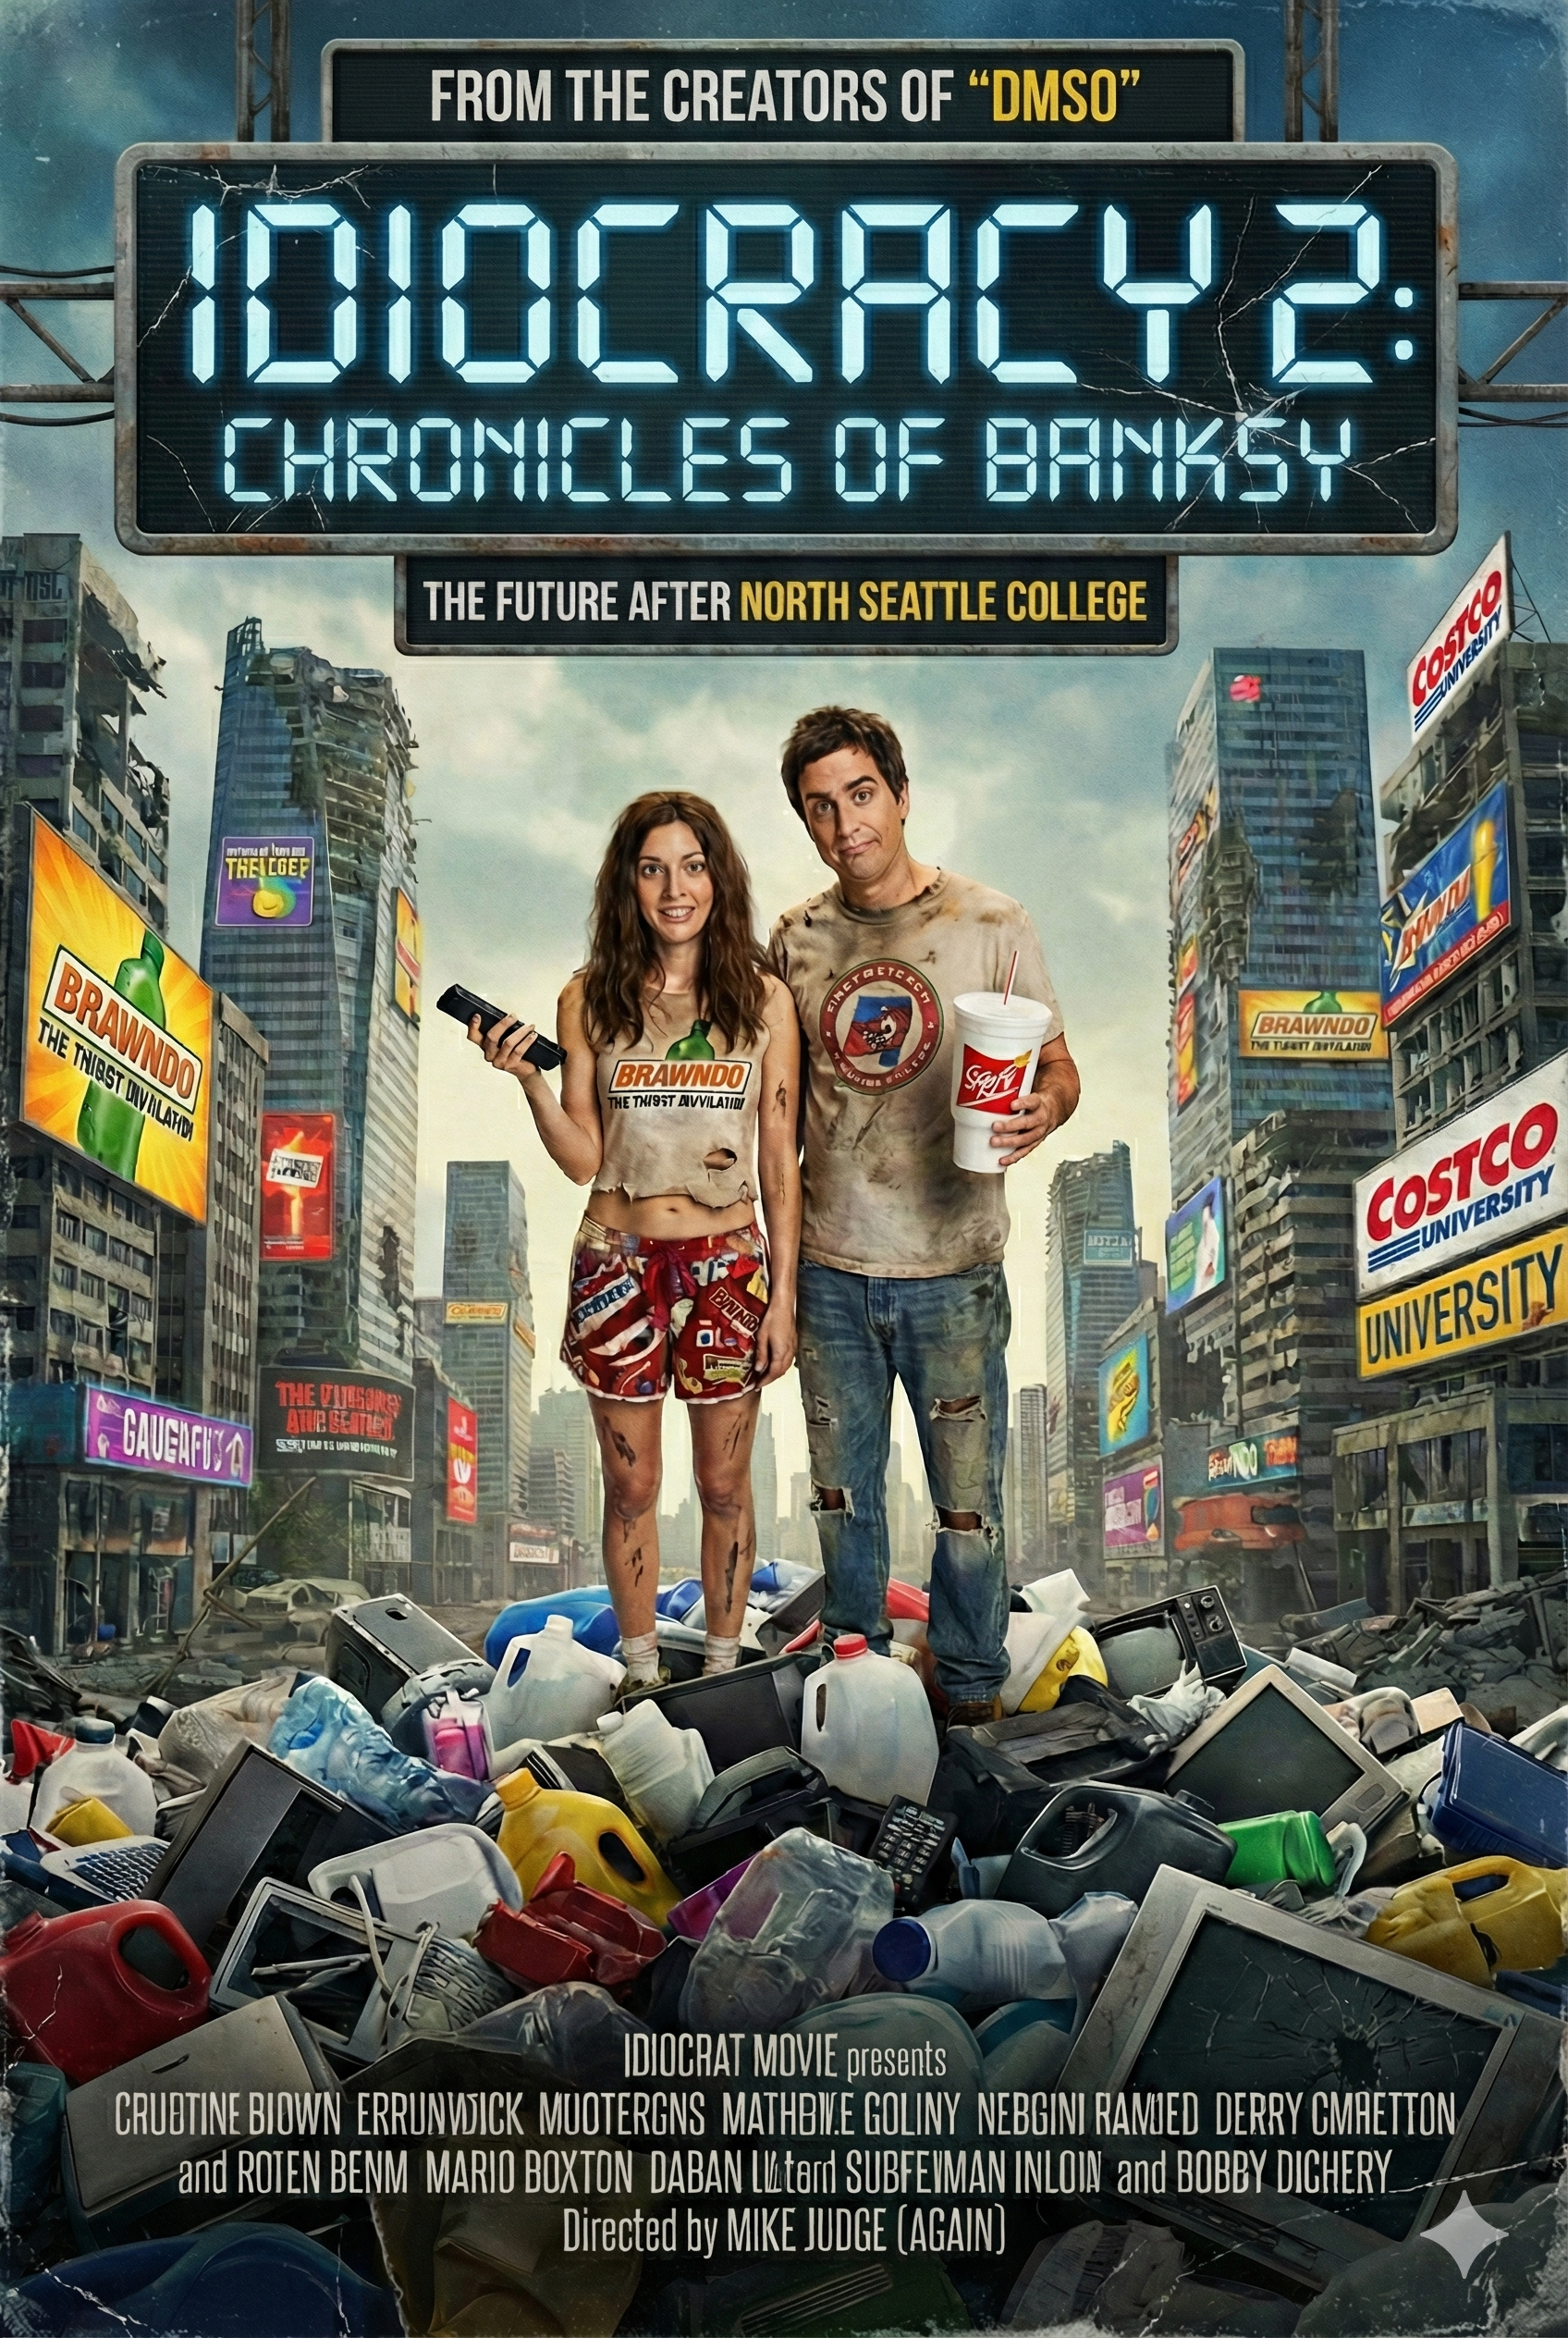

Image Idiocracy 2, Chronicles of BANKSY: THe Future After North Seattle College

Dr. Correo Hofstad

12-07-2025

University of Washington

Department of Medicine

Biochemistry 670

**The Chronicles of BANKSY: The Last Man Who Knew What Soap Was**

**A Look at the Great Sanitizer Apocalypse**

The year is... well, it doesn't matter. It’s the future. A future where evolution didn't just stop; it put the car in reverse and floored it into a wall. In this timeline, humanity has made a fatal error: they forgot that soap and water effectively remove dirt. Instead, society has become addicted to "The Gel."

In this brave new world, people don't wash their hands. They just slather on alcohol-based sanitizer because, as the marketing says, "It’s got what hands crave." 1 It tingles, so it must be working, right?

**The "Brawndo" Effect on Cryogenics**

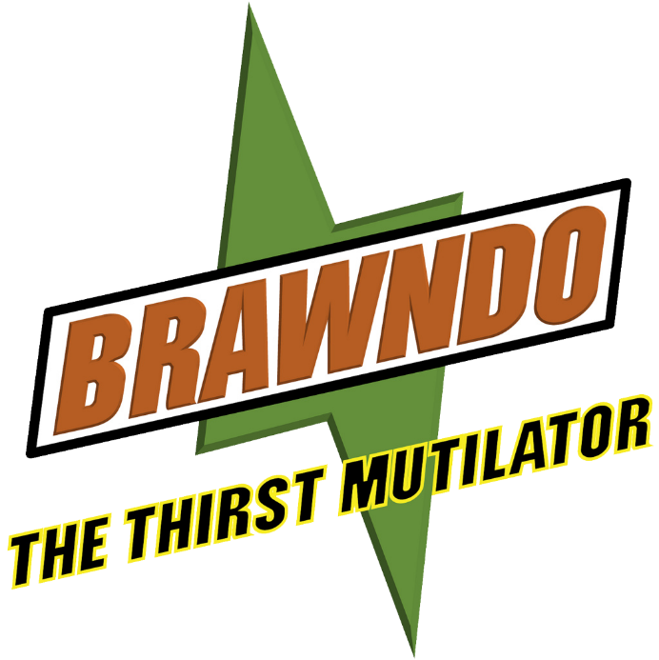Here comes BANKSY, a man out of time, wandering the halls of a research center that looks suspiciously like a frat house after a kegger. He walks past the engineering department, where the "top minds" are hard at work building a nitrogen freezer. But there's a problem.

Image Branwndo, by VirusTC (Coming Soon!)

The engineers, recruited from the prestigious "School of People Who Like Shiny Things" (formerly North Seattle College), have confused the industrial alcohol used for cleaning with a delicious beverage. Why? Because water is for toilets. Alcohol is for winners.

"Sir," one engineer says, swaying slightly while holding a wrench backward. "We finished the freezer. We put the cold air juice inside."

"You mean the liquid nitrogen?" BANKSY asks, checking his atmospheric sensors.

"Yeah, the cold stuff. It’s light, right? Like a balloon? It’ll just float away if we spill it."

BANKSY facepalms. "No! Nitrogen is heavy! If you spill it, it sinks! It’s going to fill the room like an invisible swimming pool of doom!" 2

But they don't listen. They are too busy debating whether putting Tabasco sauce in their eyes will help them see the microscopic leaks better. After all, if it burns, it’s cleaning the eye, right?

[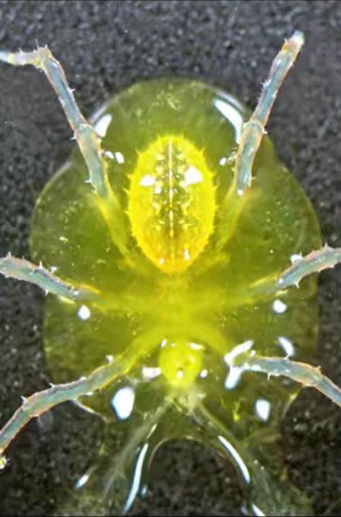](https://www.youtube.com/shorts/Ayyr0UiLT0U)**The Mystery of the Melting Viruses**

Image Dr. G wants everyone to experience a hands-on nuclear meltdown.

Meanwhile, in the lab, the head researcher—let's call him Dr. G—is staring at a puddle of what used to be a virus specimen.

"I don't get it," Dr. G says, scratching his head with a sanitizer-soaked glove. "We used the 'Super Cleaning Agent' on the viruses. The label said 'Detergent,' which I assume is French for 'Makes Things Last Forever.' But now the virus is gone!"

"That's because detergent breaks down fat!" BANKSY yells, trying to explain basic chemistry to a wall. "Viruses have lipid envelopes! You are literally washing the viruses to death with soap, but you won't wash your own hands!"

"You talk like a crazy person," Dr. G replies. "Next you're gonna tell me we shouldn't water the crops with energy drinks." 3

**The Side Quest for Princess Magret**

Suddenly, a Klaxon sounds. The nitrogen leak has begun. The engineers, realizing too late that gravity exists, have turned the basement into a foggy abyss. But amidst the chaos, a cry for help rings out.

It is Magret4, the Fairy Princess of Common Sense (and also a very confused police officer). She has been kidnapped by the "Rat Researchers"—a group of former clinical doctors who decided that curing humans was too hard because humans talk back, whereas rats just squeak and accept their fate.

"Save me, BANKSY!" Magret cries. "They're trying to sterilize me with a flamethrower because they ran out of hand sanitizer!"

BANKSY, donning his protective gear (which the others assume is a robot costume), dives into the nitrogen fog. He dodges engineers who are slipping on the floor because they tried to mop it up with Brawndo. 5

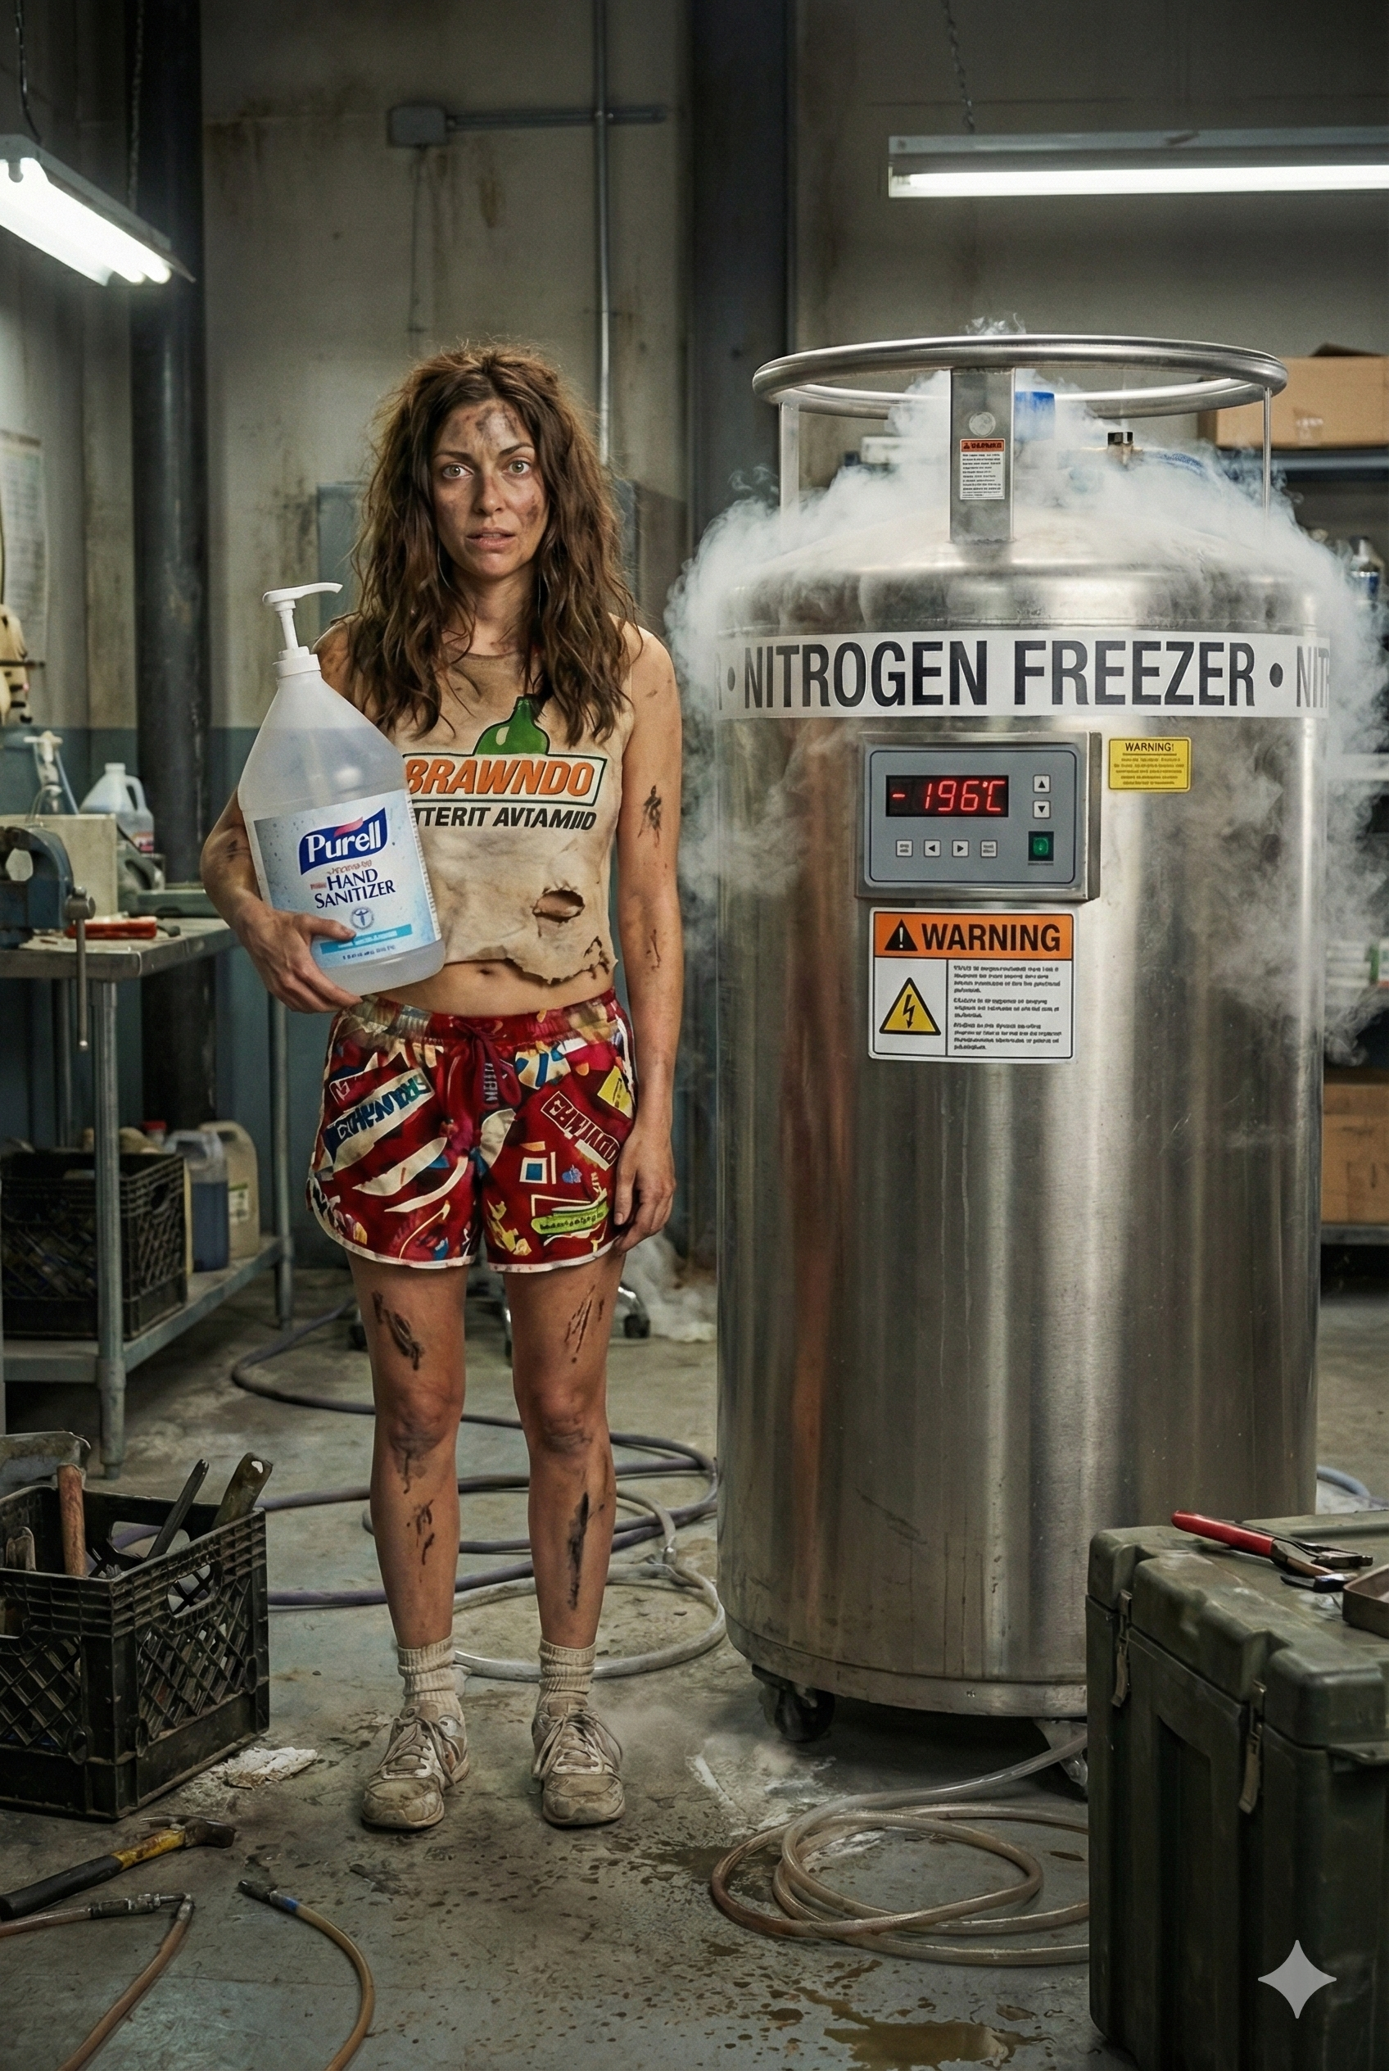

Image Magret refuses to leave her hand sanitizer behind...

**The Great Polka Dot Panic of 2025**

While the engineers were busy turning the basement into a nitrogen-filled death trap, another crisis was brewing on the surface. The entire population had turned a ghostly shade of pale, covered in what they called "Beauty Polka Dots." In reality, these were melanin spots caused by a massive, society-wide Magnesium Deficiency11.

**BANKSY**, the rogue government pharmacist (and part-time graffiti artist), was trying to save humanity one tablet at a time. He stood on a crate in the town square, holding a bottle of **MG-Neshem**, a supplement from the legendary **VirusTC** vault.

"Listen up, people!" BANKSY shouted through a megaphone. "You're not supposed to be spotted! Those aren't fashion statements; they are signals of a deep metabolic imbalance! You need magnesium to distribute your melanin evenly!"

The crowd gasped. A woman in the front row, whose face looked like a connect-the-dots puzzle, clutched her pearls. "But... if we take your magic pills, what happens to our spots?"

"They go away!" BANKSY explained enthusiastically. "MG-Neshem allows your body to crystallize melanin efficiently. It creates a uniform shield to protect your organs from the sun! You'll become healthy and... *darker*!"

Pandemonium ensued.

"Darker?!" screamed a man who was currently the color of a raw potato. "I don't want to be dark! I worked hard for these spots! They match my purse!"

"It’s a natural defense system!" BANKSY pleaded. "Magnesium is the limiting reagent for your survival! Without it, you're just walking, talking cellular degeneration!"

But the mob wouldn't listen. They were terrified of the "Darkening." In their eyes, health was a terrifying mutation. They viewed the protective, uniform distribution of melanin not as a biological shield, but as a threat to their pale, spotted identity.

"Get him!" someone yelled. "He's trying to steal our spots and turn us into... *healthy people*!"

BANKSY was forced to flee, clutching his bottles of MG-Neshem, leaving the crowd to bask in their deficiency, proudly displaying their "metabolic blemishes" as high fashion, completely unaware that they were rejecting the very thing that could save them from the sun.

**The Moral of the Story**

BANKSY grabs Princess Magret and hoists her out of the research building, but then she starts drinking hand sanitizer and claiming liquid nitrogen is a light gas, and he must leave her behind. He looks down at the chaos below: frozen engineers, melted virus samples, and a leadership team meeting to decide whether they can fix the leak by rebranding it as a "surprise spa treatment."

"Listen to me!" Hofstad shouts to the survivors. "There is an ancient technology! It is called **Soap**. And **Water**. It removes the dirt without drinking the alcohol! And for the love of science, read the labels! If it says 'Detergent,' it dissolves things!"

The crowd stares at him blankly.

"Does soap have electrolytes?" someone asks. 6

BANKSY sighs, grabs a clipboard, and starts writing a very serious safety report. Some timelines just can't be saved.

**References:**

* Allied Universal. "Coaching - Counseling - Disciplinary Notice: Cory Hofstad." *Allied Universal*, 14 Oct. 2023. 1
* "Brawndo on Grass." *N.p.*, n.d. 2
* "Explain how Key Cryoprotective Agents (CPAs) are solvents and detergents, used to preserve healthy tissue, not virus species." *N.p.*, n.d. 3
* Hofstad, Correo. "A Tragic Nitrogen Leak: Lessons Learned from Fred Hutchinson Cancer Center." *United States Marine Corps*, 20 Dec. 2024. 4
* Hofstad, Correo. "Authorization for Release of Records." *Fox Rothschild LLP*, 14 Dec. 2023. 5
* Hofstad, Correo. "Diversity Statement." *Fred Hutchinson Cancer Center*, n.d. 6
* Hofstad, Correo. "FDA Form 3500 for Health Professionals." *Fred Hutchinson Cancer Center*, May 2025. 7
* Hofstad, Correo. "Nitrogen and Sabotage: Dr. Germán Gornalusse and North Seattle College Cover Up Deaths At Fred Hutchinson Cancer Center." *Virus Treatment Centers*, 21 May 2025. 8
* Hofstad, Correo. "The Irrefutable Truth: Cory Hofstad's Top Secret SCI Full Scope Polygraph Security Clearance and Its Impact on Retaliation Claims." *Washington State Department of Licensing*, 12 Apr. 2025. 9
* Hofstad, Correo. "Unraveling the Mysteries of Cryogenic Preservation: Lessons from the University of Washington." *Virus Treatment Centers*, Apr. 2025. 10
* Hofstad, Correo. "Illuminating the Darkness: How Virus Treatment Centers and MG-Neshem Are Transforming Retinitis Pigmentosa Treatment." *Virus Treatment Centers National Laboratories*, 24 July 2025. 11

**Dr. Correo “Cory” Andrew Hofstad Med Sci. Educ, PO, ND, DO, PharmD, OEM, GPM, Psych, MD, JSD, JD, SEP, MPH, PhD, MBA/COGS, MLSCM, MDiv**



**Virus Treatment Centers [VirusTC]**

(425) 400-5893

[drhofstad@virustreatmentcenters.com](mailto:drhofstad@virustreatmentcenters.com)